Project Name & Introduction

Project Title: Online Exam Portal System
Description: An online platform where users can register, browse exams, attempt tests online, and receive results instantly. Administrators manage exams, questions, and analytics using a scalable microservices architecture.

Team Members

Sumit Kumar [2478516] – User Management Service
Mahesh T [2479482] – Exam Management Service
Bharath Kumar K [2480058] – Question Bank Service
Eswar Reddy [2478611] – Exam Attempt Service
Rudra Narayan Biswal [2478663] – Result & Analytics Service
Team Size: 5 Members

Technologies, Languages & Tools

Backend: Spring Boot (Java)
APIs: RESTful Web Services
Security: JWT Authentication
Database: MySQL
Tools: Git, Postman, IntelliJ IDEA

Project Introduction & Focus Areas
The Online Exam Portal focuses on delivering a secure, scalable, and efficient examination system.
Main Modules:
• User Management Module
The User Management Module is responsible for handling all user related activities in the system. It allows users to register, log in securely, and manage their personal profiles. This module also manages authentication and authorization using JWT (JSON Web Token) to ensure secure access to the application. Different user roles such as Admin and Student are maintained to control access to specific functionalities.
Key Features:
- User Registration and Login
- Secure Authentication using JWT
- Role-based access (Admin / User)
- Profile management

• Exam Management Module
The Exam Management Module enables administrators to create, update, schedule, and manage exams within the portal. Admins can activate or deactivate exams and define exam details such as duration, total marks, and timing. This module ensures that exams are available to users only during the scheduled time.
Key Features:
- Create and update exams, subject
- Schedule exam date and time
- View available exams

• Question Bank Module
The Question Bank Module manages all exam questions in a centralized repository. Admins can add, edit, delete, and categorize questions. Questions can be mapped to specific exams and may contain multiple‑choice options. This module ensures efficient reuse of questions across different exams.
Key Features:

Add, edit, and delete questions
Manage question options
Map questions to exams
Store questions securely in the database

• Exam Attempt Module
The Exam Attempt Module handles the complete exam-taking process for students. It allows users to register for an exam, attempt questions within a specified time limit, and submit answers. A timer is maintained to ensure fairness and accuracy during the examination.
Key Features:
- Register for exams
- Start exam and attempt questions
- Timer handling
- Submit answers securely

• Result & Analytics Module
The Result & Analytics Module evaluates submitted answers and generates results automatically. It calculates scores, maintains attempt history, and displays analytics such as performance reports and leaderboards. This module provides useful insights for both students and administrators.
Key Features:
- Automatic answer evaluation
- Result generation
- Leaderboard and ranking
- Attempt history and analytics reports

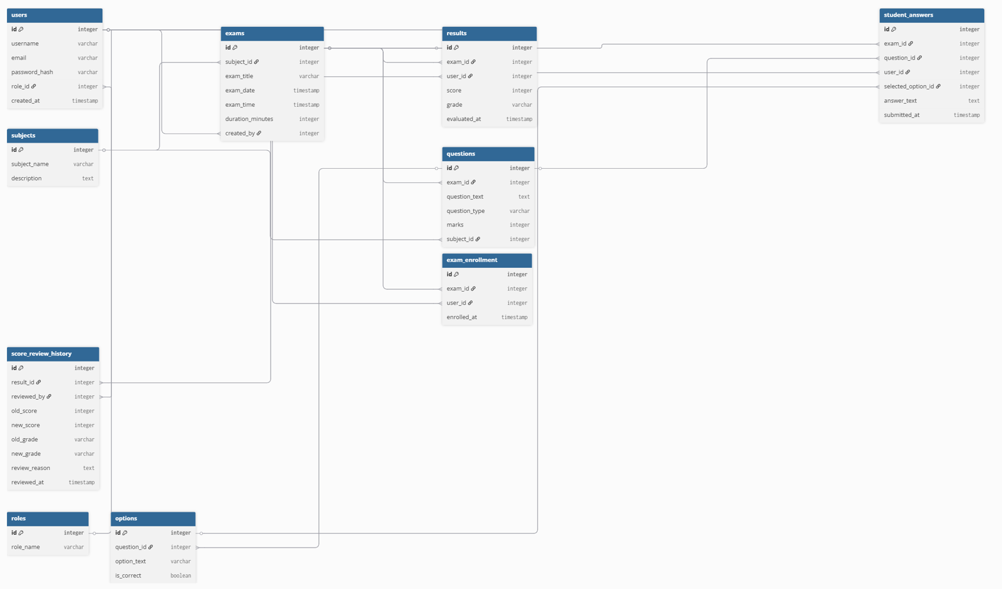
ER Diagram & Architecture

Future Enhancements

• Frontend UI using React
• Unit & Integration Testing (JUnit, Mockito)
• Advanced Analytics & Reports
• Certificate Generation
• Improved UI/UX

